JavaScript Assignment #1

**Part 1: About Me**

[Page Your A1P1 Screenshot Here, then paste your code below it]

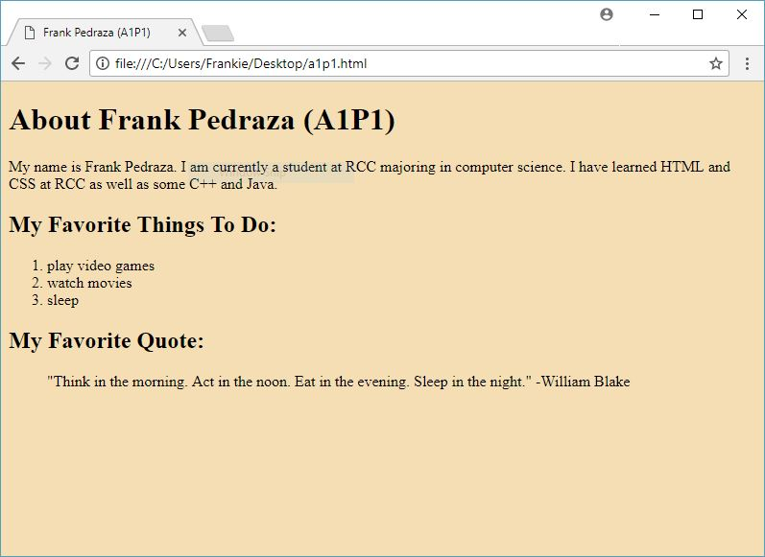

[Paste your A1P1 Code Here, Below the Screenshot]

<!doctype html>

<html>

<head>

<meta charset="utf-8">

<title>Frank Pedraza (A1P1)</title>

</head>

<body style="background-color: wheat;">

<h1>About Frank Pedraza (A1P1)</h1>

<p>My name is Frank Pedraza. I am currently a student at RCC majoring in computer science. I have learned HTML and CSS at RCC as well as some C++ and Java.</p>

<h2>My Favorite Things To Do:</h2>

<ol>

<li>play video games</li>

<li>watch movies</li>

<li>sleep</li>

</ol>

<h2>My Favorite Quote:</h2>

<blockquote>"Think in the morning. Act in the noon. Eat in the evening. Sleep in the night." -William Blake</blockquote>

</body>

</html>

**Part 2: About Document.Write**

[Paste your part 2 code below]

<!doctype html>

<html>

<head>

<meta charset="utf-8">

<title>Frank Pedraza (A1P2)</title>

</head>

<body style="background-color: wheat;">

<h1>About Frank Pedraza (A1P2)</h1>

<p>My name is Frank Pedraza. I am currently a student at RCC majoring in computer science. I have learned HTML and CSS at RCC as well as some C++ and Java.</p>

<script>

document.write('<h2>My Favorite Things To Do:</h2>');

document.write('<ol>');

document.write('<li>play video games</li>');

document.write('<li>watch movies</li>');

document.write('<li>sleep</li>');

document.write('</ol>');

document.write('<h2>My Favorite Quote:</h2>');

document.write('<blockquote>"Think in the morning. Act in the noon. Eat in the evening. Sleep in the night." -William Blake</blockquote>');

</script>

</body>

</html>

**Part 3: Temperature Conversion**

[Page Your A1P3 Screenshot Here, then paste your code below it]

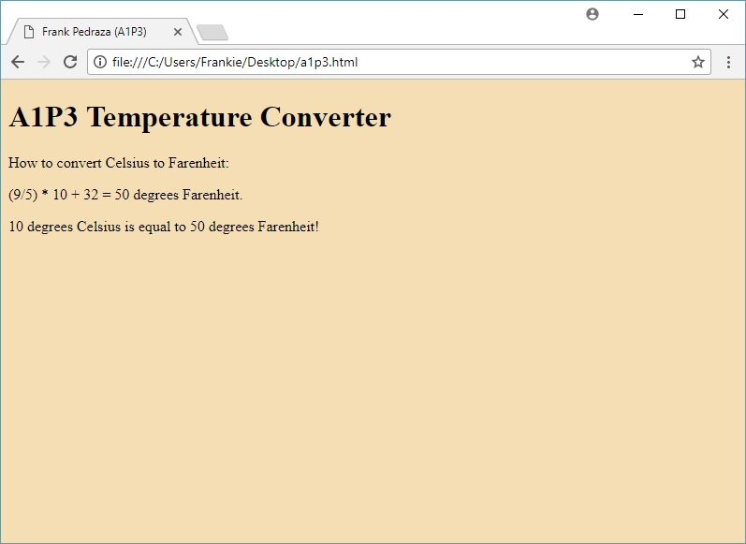

[Paste your A1P3 Code Here, Below the Screenshot]

<!doctype html>

<html>

<head>

<meta charset="utf-8">

<title>Frank Pedraza (A1P3)</title>

</head>

<body style="background-color: wheat;">

<script>

document.write('<h1>A1P3 Temperature Converter</h1>');

var cel=prompt('What is the temperature in Celsius?');

var faren=(9/5)*cel+32;

document.write('<p>How to convert Celsius to Farenheit:</p>');

document.write('<p>(9/5) * '+cel+' + 32 = '+faren+' degrees Farenheit.</p>');

document.write('<p>'+cel+' degrees Celsius is equal to '+faren+' degrees Farenheit!');

</script>

</body>

</html>

**Part 4: Alert -- It’s Freezing in Here!**

[Paste your part 4 code below]

<!doctype html>

<html>

<head>

<meta charset="utf-8">

<title>Frank Pedraza (A1P4)</title>

</head>

<body style="background-color: wheat;">

<script>

document.write('<h1>A1P4 Temperature Converter</h1>');

var cel=prompt('What is the temperature in Celsius?');

var faren=(9/5)*cel+32;

document.write('<p>How to convert Celsius to Farenheit:</p>');

document.write('<p>(9/5) * '+cel+' + 32 = '+faren+' degrees Farenheit.</p>');

document.write('<p>'+cel+' degrees Celsius is equal to '+faren+' degrees Farenheit!');

if (faren<=32) {

alert(+cel+' degrees Celsius is equal to '+faren+' degrees Farenheit! AND THAT IS FREEZING COLD!');

}

</script>

</body>

</html>